# Unit 7 Assignment

# Amon-Ra

# Herzing University

BU 642-8 Business and Labor Law

**INTRODUCTION**

This paper will analyze law and its role in business. The paper will include historical exhibition of the foundation of law and its rise from the philosophy of ethics. Formal institutionalization of ethics, in the form of law, will be demonstrated in the processes of the legislative, judicial, and executive branches of government and their respective duties to create interpret, and enforce law. The major categories of law, administrative/regulatory, criminal and civil, will be examined regarding its effects on business and its operations.

**ORIGIN OF ETHICS**

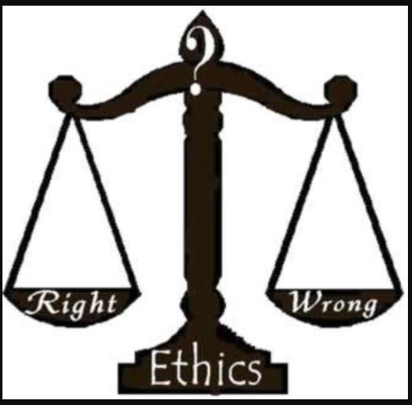Good versus bad, right versus wrong, correct versus incorrect, these are the opposing opposites and questions that we ask ourselves daily whereby judgement is made. How to decide what falls under which category? This gauging or weighing of available courses of actions against a system of thought that serves as the rule of measurement is the body of philosophy known as the theory of ethics.

Figure I. Ethical Judgement

“Philosophy is a way of thinking about certain subjects such as ethics, thought, existence, time, meaning and value.” ("WHAT IS PHILOSOPHY?", n.d.)

“Ethics, rather, emphasizes the responsibility and capability of the individual to come to his/her own conclusions through reasoning, and to determine which principles are relevant in a particular case. They are well-founded standards of right and wrong that prescribe what humans ought to do, usually in terms of rights, obligations, fairness, or specific virtues. Ethics is the reasonable obligation for us to refrain from hurting others, and sometimes an obligation to help others.” (Gomez, n.d.)

Ethics evolve from and revolve around the individual’s values which is later transferred to others thus becoming the group’s values. This can help explain how right and wrong can change over time and become widely adhered to. A study dedicated to the development of ethics arose seeking to inform the public of ideal character. These schools are known as the theorical schools of thought.

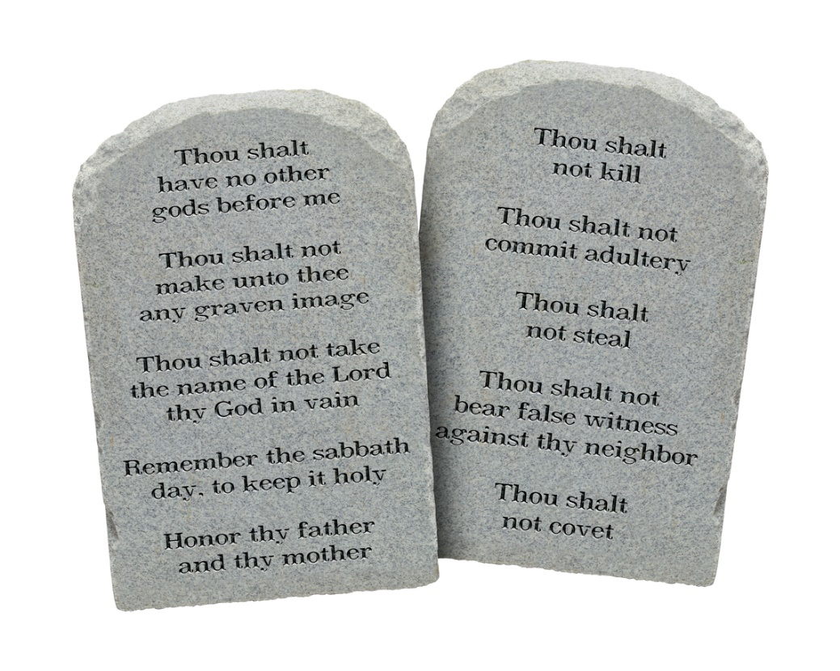Ethics can stem from values centered around consequences, such personal or group interests as defined in the philosophical egoism and utilitarianism theorical schools of ethics. Additionally, among the schools is a generalized value of ethics within the Deontology theorical school of ethics that presents a set of principles that all should follow regardless of the outcome. An example of the value of the generalized Deontology theorical schools of ethics would be the 10 commandments.

**Figure II. The 10 Commandments**

The 10 Commandments are most popular in religious groups but some of the commandments have transcended the religious application and found to be a part of society at-large, expanding various countries and even continents.

A third theorical school is that of the ethics of virtue, which calls for the development of valued qualities by creating a harmonious balance between opposite extremes that are termed deficiencies and excesses. A metaphorical example would be to avoid water that is too hot and water that is too cold by identifying the equilibrium of both by using warm water. The following is not the directly from the virtues of Aristotle’s school of virtue but an illustration of the application of philosophy:

## Learn to be strong but not impolite.

## Learn to be kind but not weak.

## Learn to be bold but not a bully.

## Learn to be humble but not timid.

## Learn to be proud but not arrogant.

## Learn to develop humor without folly. (Rohn, 2017)

## FROM ETHICS TO LAW

## Ethics assist to develop certain traits in people which has as effect on behavior. It is only one’s own consciousness to which to answer to when deviating from what is determined to be right. Is “a guilty conscious” powerful enough to ensure ethics are adhered to? It is not enough to appeal to the rationale of an individual.

## Among individual ethics can and will differ. In order to create a functional society, there must be order and common goals. The common “good” of ethics created the necessary order but ethics is informal and may not be accepted by everyone nor can it be enforced. As demonstrated with the 10 commandments, ethics are principles that can be applied in a universal manner to govern all areas of life and a variety of situations. Ethics in the form of the 10 commandments define right and wrong for a group. Within the context of a group ethics.

## Just as ethics define what is right and wrong from personal and group perspective, laws define right and wrong behavior for the entire geographical locations under an official governing body. From ethics came forth the laws that govern society. Institutions were erected around principles of ethics wherein they create and enforce the ethics in the form of laws.

## In the United States of America, there 3 sections of the government that is responsible for laws. Those 3 parts of the government are referred to as the 3 branches of government:

## Legislative – creates the laws.

## Executive – enforces the laws.

## Judicial – Interprets the laws.

## The legislative body of government consist of two parts: House of Representatives and the Senate which are made up of persons elected by the population to represent them or speak from them in legislative sessions. Elected officials meet to discuss and create what will considered right and wrong (legal and illegal) for the country. The elected officials from each state convene in the House of Representatives to vote, debate or amend the idea for a law presented in the form of a bill.

## If agreed upon by the House of Representatives the bill will be passed to the Senate to undergo the same process of debate or amendment. A group of officials from both legislative bodies will create a consolidate the two versions of the bill to be presented to the president in order to be signed into law or vetoed.

## The laws created by the legislature are referred to as federal statutes and govern the entire country. Federal statutes may not include all the details regarding the application of the law. Congress will create federal agencies to provide the details and enforcement of congressional/federal law. Through these agencies federal regulations created.

## Laws at the federal level have a residual effect, cascading down from national to state to local affecting both private and public lives, businesses and individuals. Legislature at the state level convene to make laws based on federal statutes. The state laws are known as state statutes.

## An example of a federal regulation:

## “The Privacy Act of 1974, as amended, 5 U.S.C. § 552a, establishes a code of fair information practices that governs the collection, maintenance, use, and dissemination of information about individuals that is maintained in systems of records by federal agencies. A system of records is a group of records under the control of an agency from which information is retrieved by the name of the individual or by some identifier assigned to the individual.” ("Privacy Act of 1974", 2020)

## Part b Conditions of Disclosure of the Privacy Act of 1974 provides the following:

## “(b)Conditions of Disclosure.—No agency shall disclose any record which is contained in a system of records by any means of communication to any person, or to another agency, except pursuant to a written request by, or with the prior written consent of, the individual to whom the record pertains, unless disclosure of the record would be.” ("Privacy Act of 1974", 2020)

## Various businesses collect and maintain information on customers. With the boom of the internet, websites, online shopping, ecommerce, customer information collection has grown and potential places customer at risk for such identity theft, fraudulent purchases, and a host of other wrongs. Customer information collected by businesses is sensitive and should be treated as such in order avoid harm to customers. The Privacy Act of 1974 establishes the right and wrong behavior in handling customer information. It helps to establish best practices to prevent harm to the customers and enforces penalties when the law is violated by businesses. help customer information.

## There are several additional regulations in existence that serve to specifies right and wrong in order establish the acceptable behavior. A few those additional regulations address the following:

## Fair Credit Reporting Act

## Privacy Act

## Americans with Disabilities Act (ADA)

## Family and Medical Leave Act

## Workers’ Health and Safety Rights and Whistleblower Protection

## Workplace Discrimination Laws

## Prohibited Employment Policies/Practices

## When a violation of laws takes place, whether civil or criminal, addressing the issues can take place in civil and/or criminal legal proceedings. Criminal proceedings seek to punish the person(s) involved in perpetrating the behavior and civil proceedings seek to compensate the person(s) affected by the behavior.

## In a civil suit various actions can be awarded to plaintiff as a means of remedying the loss or injury incurred:

## Declarative – Announces the plaintiff as the party to have prevailed in the legal action.

## Injunctive – Instructs a specific act to be performed or cease to be performed by the defendant.

## Punitive – Imposes punishment on the defendant.

## Compensatory – Awards monetary damages to the plaintiff as compensation.

## BUSINESS LIABILITY

## When businesses violate the law criminal and civil penalties can be imposed by government agencies. Consumers affected by the actions of a business have civil remedies available as a means of addressing the wrong. Does is not take a human being working for the company to perform the action that is in violation of the law? If an employee is responsible for the behavior, why is not the employee ultimately responsible? Depending on the actions, criminal and civil penalties may be imposed, yet the law regarding business liability and the business structure will decide the extend of responsibility on the part of the business.

## Business StructuresBUSINESS STRUCTURES

4 basic legal business structures:

1. Sole proprietorship is a simple business structure. The business itself is not a legal entity and is a part of owner’s personal assets. In being an extension of the owner, the sole proprietor, sole owner, is responsible for all debts of the business. When a legal issue arise, the owner will be sued. Business assets and personal do not exist for everything exists as business assets.

Figure III. Legal Business Structures

1. Partnership involves two or more people having ownership of the business. It too is a simple business structure much like that of sole proprietorship. The business is an extension of the owners with no legal separation between the business and its owners. All owners will share in the responsible debts and actions of the business.
2. Limited liability company involves the owner or owners. The income of the business is reported on the income tax returns of the owners. The owner(s) are not responsible for the debts of the business. All responsibility falls on the business.
3. Corporation is a totally separate legal entity. The taxes of the corporation and all debts are the sole responsibility of the business. This means that the income of the corporation is never reported on a person income tax return.

## From the review of the 4 basic legal business structures, the business is always responsible. What differs among each business structure is the extend of responsible and whether it will impact the assets of the owners. Business actions include the actions of employees whether intentional or unintentional and known or unknown. The business is responsible all business actions and inaction.

## The responsibility of the relationship between the employer and employee is known as vicarious liability. Vicarious liability defines that employers (supervisors) bear the burden of being responsible for employees (subordinates). Why should this be? After all, we are all adults and every adult should be responsible for his or her actions.

## The benefit of the actions of employees is that of the business. The employee doesn’t benefit from the action, the business is the one benefiting. Is an employer responsible for any and all actions of an employee, whether during working hours, outside working hours, on company premises or off company premises? A respondeat superior test is used to gauge the responsibility.

## “Benefits Test - When the employee’s social or recreational pursuits on the employer’s premises after hours are endorsed by the express or implied permission of the employer and are conceivably of some benefit to the employer, then the employer is liable for harm resulting from the employee’s actions.” ("Respondeat Superior", n.d.)

## “Characteristics Test - If the employee's action is common enough for that job that the action could be fairly deemed to be characteristic of the job, then the employer will be liable for harm resulting from the employee’s actions.” ("Respondeat Superior", n.d.)

## Vicarious liability provides a safeguard against Plausable Deniability. “Plausable deniability refers to circumstances where a denial of responsibility or knowledge of wrongdoing cannot be proved as true or untrue due to a lack of evidence proving the allegation. This term is often used in reference to situations where high-ranking officials deny responsibility for or knowledge of wrongdoing by lower ranking officials.” ("Plausable Deniability Law and Legal Definition", n.d.)

## BUSINESS ETHICS

Just as regulations are created to provide additional details in the enforcement of federal legislation, companies create codes of ethics. A code of ethics is sometimes referred to as a code of conduct. A code of conduct/ethics defines what behavior is expected from every employee and helps to create a specific company culture and environment. All policies within the code of ethics are based on government laws and regulations.

Having a code of ethics is good for business. The benefit is not isolated to the business. Employees, business partners, and customers also enjoy in the benefits of companies doing what is right in transacting business. Sometimes, ethics can extend beyond business and impact other areas such as environmental and community issues. This can lead to volunteering for neighborhood cleanups, paperless environment policy, food drives, clothing drives, internship programs, career event programs etc. Such ethics can create an obligation to act and perform a certain task regardless of the outcome as in the Deontology theorical school of ethics. It simply becomes the right thing to do.

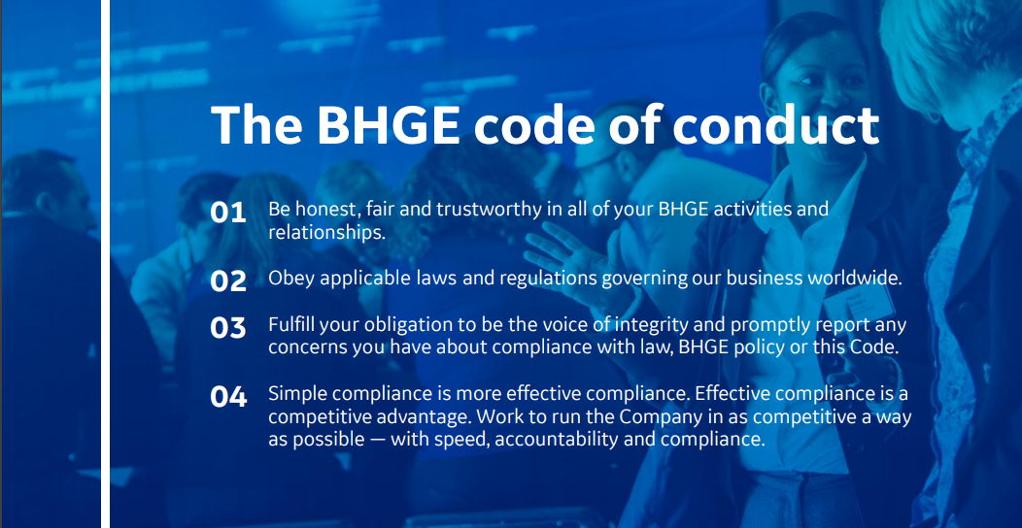

Figure IV. Baker Hughes General Electric Code of Conduct

**CONCLUSION**

Ethics is matter of right and wrong. That right and wrong can evolve from individual or group values. The study and pursuit of the ethics were incorporated into ethical theorical schools of thought. The right and wrongs behavior, established through ethics, eventually took the form of law to govern entire societies regarding behavior. This is necessary in order to have a functioning society. Laws extend to every sector including the business sector. When business violate those laws, they are held accountable. The extend of the accountability is based the legal structure of the business. To create the right business environment that is conducive toward fostering growth, companies will create a code of ethics for all members of the company to adhere to.

## References

## Business Structures. (n.d.). Retrieved April 19, 2020, from http://www.legalflip.com/Article.aspx?id=33&pageid=170

## Damages. (n.d.). Retrieved April 19, 2020, from https://www.law.cornell.edu/wex/damages

## Enriquez, J. G. (2017, November 26). Ethics 101: Elements of Ethics in Research Design. Retrieved from https://medium.com/@jgenriquez/ethics-101-elements-of-ethics-in-research-design-db631e8b7af7

## Gomez, M. A. (n.d.). Introduction to Ethics. Retrieved April 18, 2020, from https://courses.lumenlearning.com/atd-epcc-introethics-1/chapter/what-is-ethics/

## Limited Liability Company Definition - Entrepreneur Small Business Encyclopedia. (n.d.). Retrieved April 19, 2020, from https://www.entrepreneur.com/encyclopedia/limited-liability-company

## Plausable Deniability Law and Legal Definition. (n.d.). Retrieved April 19, 2020, from https://definitions.uslegal.com/p/plausable-deniability/

## Privacy Act of 1974. (2020, January 15). Retrieved from https://www.justice.gov/opcl/privacy-act-1974

## Respondeat Superior. (n.d.). Retrieved April 19, 2020, from https://www.law.cornell.edu/wex/respondeat_superior

## Rohn, J. (2017, February 15). 7 Personality Traits of a Great Leader. Retrieved from https://www.jimrohn.com/7-personality-traits-great-leader/

## Sole Proprietorship Definition - Entrepreneur Small Business Encyclopedia. (n.d.). Retrieved April 19, 2020, from https://www.entrepreneur.com/encyclopedia/sole-proprietorship

## The Basics of the Regulatory Process. (2019, September 5). Retrieved from https://www.epa.gov/laws-regulations/basics-regulatory-process

## The Legislative Process. (n.d.). Retrieved April 18, 2020, from https://www.house.gov/the-house-explained/the-legislative-process

## The Spirit & The Letter - BHGE. (n.d.). Retrieved April 19, 2020, from https://www.bhge.com/system/files/2018-03/BHGE Spirit and Letter English_FINAL.pdf

## Wells, B. (2019, February 4). Ten Commandments in Texas Classrooms: But What Version? Retrieved from https://news.utexas.edu/2019/02/04/ten-commandments-in-texas-classrooms-but-what-version/

## WHAT IS PHILOSOPHY? (n.d.). Retrieved April 18, 2020, from https://www.philosophy-foundation.org/what-is-philosophy